**Cyclist Bike Share Analysis Report**

**C M Mona Lancy  
GUVI – Business Analytics and Digital Marketing  
Batch: DMT2**

**PROCESS**

This phase of the analysis process includes cleaning the data and making sure it is fit for purpose. As well as making any modifications necessary.

PowerBI was used for the data processing phase of this project. A summary of the cleaning and manipulation done to the data is presented below:

1. Combined all twelve individual months into a single data frame called “Combined Trips”.
2. Created new columns to extract the day, month, year and day of the week of each ride entry.
3. Created a new column calculating the length of each ride from the difference between the recorded “end time” and “start time” of each ride entry.
4. Changed the “ride_length” from time datatype to numeric datatype.
5. Deleted all the rows in the data frame with a null entry.
6. Deleted entries with ride length less than zero.
7. Created a new data frame that did not include the longitude and latitude columns as they were not needed for the following analysis.
8. Created a new data frame where the “started_at” and “ended at” locations were combined to get an aggregate route of each ride/trip.
9. Ordered the months from June 2021 to May 2022 and the days of the week from Sunday to Saturday.

**ANALYZE**

Analyzing the data to find patterns, relationships and trends.. A summary of the insights gleaned from the data analysis is presented below:

1. There were six hundred thousand more recorded rides by member riders over casual riders. But the casual riders spent more than two times as many minutes in their rides than the member riders. Casual riders also experienced a maximum average ride length much higher than than that of the member riders per month.

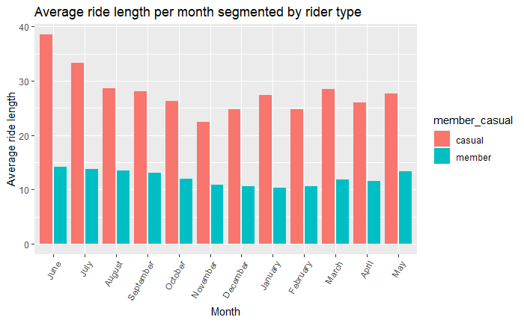

2. Casual riders experienced a peak in July while member riders experienced theirs in August. Both riders also experienced a year low in January.

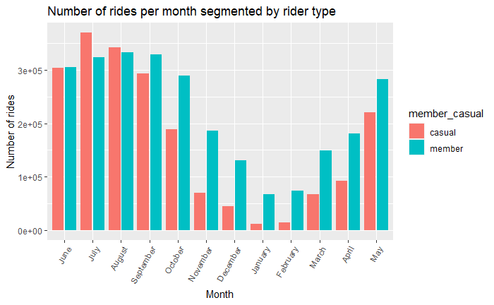

3. Casual riders went on the most rides on Saturdays whilst member riders went on the the most rides on Tuesday.

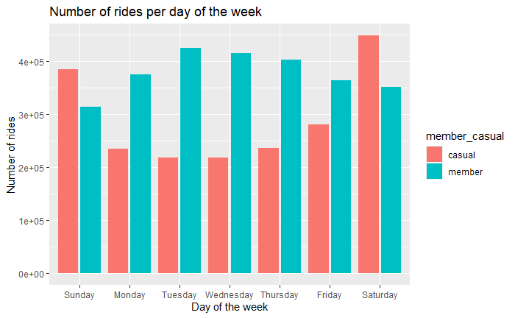

4. The most common rideable type in the recorded period was the classic bike. Both rider types recorded the most rides with the classic bike. However, the member riders did not make use of the docked bike at all.

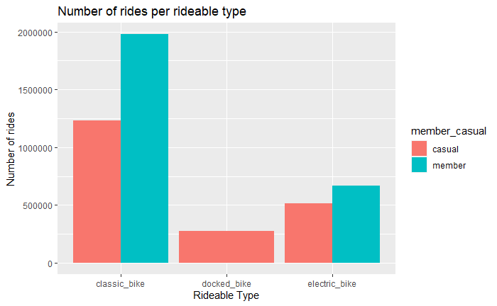

**SHARE**

Findings are shared and communicated to the relevant stakeholders.

The share phase for this project was completed using PowerBI. Dashboards created with the visualizations also present relevant information at a glance.

# ACT

After the data has been processed, analysed and insights have been shared, the final phase is to recommend a plan of action for the bikeshare company in line with their business task and objectives. My recommendations are:

1. Cyclistic already has single ride and full day passes, but it could be worth it to introduce a new monthly/seasonal plan for riders. The data shows that the number of rides casual riders go on is greatly affected by the season or the weather. Many rides in the summer from June to September and very few rides in the winter from November to February. Cyclistic can offer free membership for a full month to any casual riders that are interested in the service. It would be best to do this in the winter months where riders don't use the service as much. If they enjoy the perks of a full membership in these months or seasons, it could convince them to subscribe for more months and ultimately purchase a full annual membership.
2. Another way to convert casual riders into full time members could be targeted physical ads and campaigns. The data extracted from the past 12 months gives us insight into the most frequently used start and end stations used by casual riders as well as the routes they use on their rides. Billboards and posters are a lot more useful if the company already knows exactly where the target audience will be.
3. Cylistic can provide financial incentives for member riders and start a campaign that shows how subscribing for a full year is cheaper in the long run than subscribing only for the days in the summer months like casual riders usually do. They could also provide coupons or bonuses that encourage even more frequent rides. An example of one such incentive could be a weekly scoreboard showing the number of rides and ride length for each casual rider that chooses to participate with the winner at the end of the month getting a seasonal pass or annual membership as a reward. If casual riders can be convinced to take the bike out more frequently every week, they will ultimately see the benefit in simply subscribing to a full plan that allows them use it whenever they like.

# CONLUSION

Over the course of this project, I have been able to use a variety of tools to clean, process, analyze and visualize data, as well as draw meaningful insights from it